**5 Post-prototype refinement of design**

5.1 Obtain feedback from competent third parties.

Having presented my prototype to my class, I gained valuable competent third-party feedback from my Computer Science teacher.

These are the comments she made about my prototype and whether or not I will accept or reject her decisions:

**“You should add additional options when booking transport. Should bands have the ability to select where they want a return or one way – trip and add a section for additional comments for special requirements etc”**

Yes, I am going to take into account this feedback because it is vital that the bands are able to properly enquire about a booking they wish to make. This is for a number of reasons; to ensure the band can get a true reflected quote for their journey and so that the bus company will not need to query any more information, before they can give them a price and availability.

**“When a Pipe Major updates members details, the member should be sent an email or equivalent to ensure they are aware that their information has been edited. The same goes for admins. If an admin makes a change on behalf of the band, the pipe major must be made aware of these, an email can be sent again to notify the Pipe Major of these changes.”**

This is a really good suggestion. It is very important that whether the Pipe Major or admin enters a competition, books transport, or edits information stored about any member or the band itself, the Pipe major is sent an email to confirm with them that the change has occurred. When details about a member with in the band are updated, the member should also receive and email letting them know that their details have been updated.

**“Could you make it easier for the pipe major of a band to see which competitions they have entered, could you have another screen off the entering competitions page to allow for this? Will this feature then allow for pipe majors to withdraw from competitions?”**

Yes, I like this idea! This additional feature will improve the usability of my system as currently the only way that pipe majors can view which competitions that the band has entered is through the email send on confirmation of entering each competition. I will be able to display all the competitions that the bands have entered in a list box and beside the name of the competition, I will have the date of the competition. This allows the pipe major to see which date the competitions are which is the most important piece of information that the pipe major needs as this is when the competition is being held.

Bands will only be able to withdraw from a competition if the draw for the competition hasn’t already happened, otherwise if they select a competition from the list where the draw has already occurred, they will be told they are unable to withdraw from this competition due to the draw for the competition has already taken place.

5.2 Refine designs in light of the evaluation of the prototype solution and feedback received from others.

From my feedback and my evaluation, I have refined my prototype to include the changes that have been suggested by my teacher and my self-reflection of my prototype in the previous section.

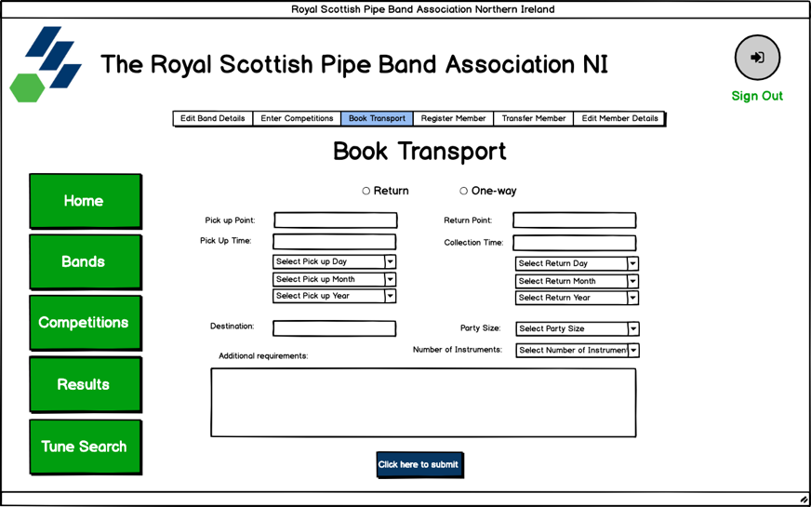I have fully refined the book transport frame in light of my teachers’ feedback. I have added radio buttons so that the band is able to select which type of trip they would like to book. I have also included an additional comments section. I feel this is very important as bands can explicitly make sure the bus company of any other requirements they might need in the initial contact with the company – this will speed up the process for the bus company.

I have updated my DFD to include the additional outputs to my system, these include:

* Email pipe major when band details are changed.
* Email pipe major to confirm the entering of a competition.
* Email pipe major with a copy of the enquiry sent to the Bus Company.
* Email pipe major when a new member is registered.
  + Email the newly registered member to confirm their registration.
* 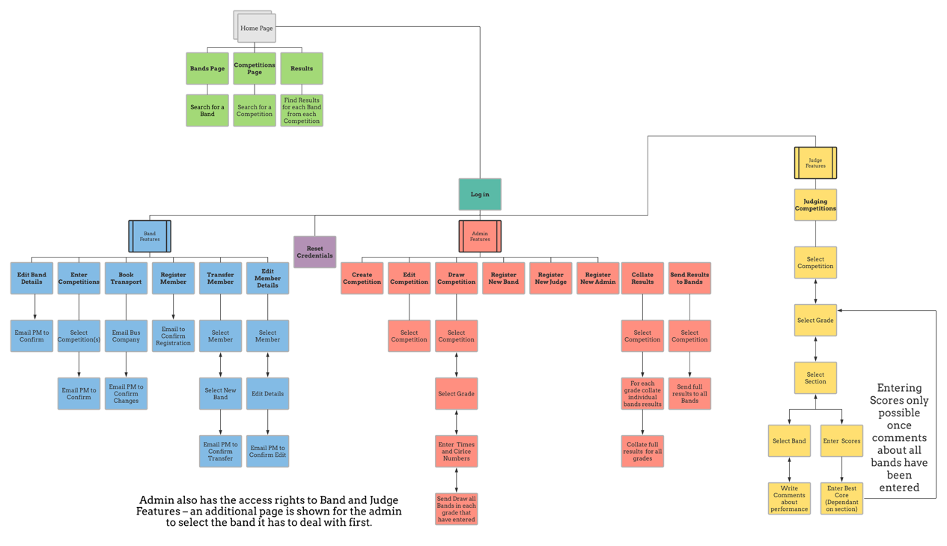Email member when their details have been updated.

These additional outputs will not be too hard to implement into my system. After the changes have been saved by the pipe major or admin and committed to the database, I will be able to send a quick email to the corresponding people to ensure they are aware of the changes that have been made.

When the details about a band have been edited by the pipe major of the band or the admin, I must send the email to the new email address that has been saved to the database. This ensures that the email confirmation won’t be sent to the old email address of the pipe major. The email will be formatted as follows:

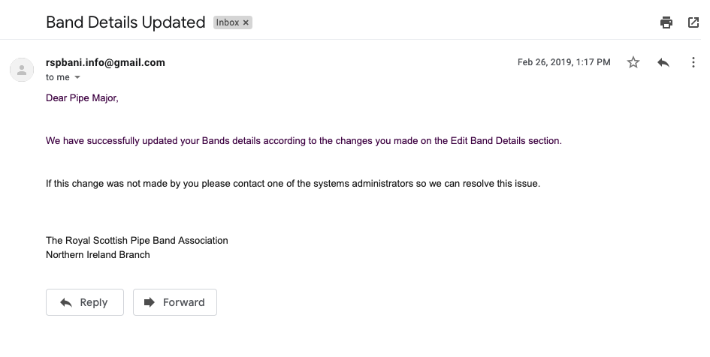

Again, when the details of a member are updated, the pipe major will be emailed to confirm these changes. The member of those details will also be emailed, and their email must include their new details so they can check themselves and if they are not correct the steps, they must take to resolve the issue will be included also.

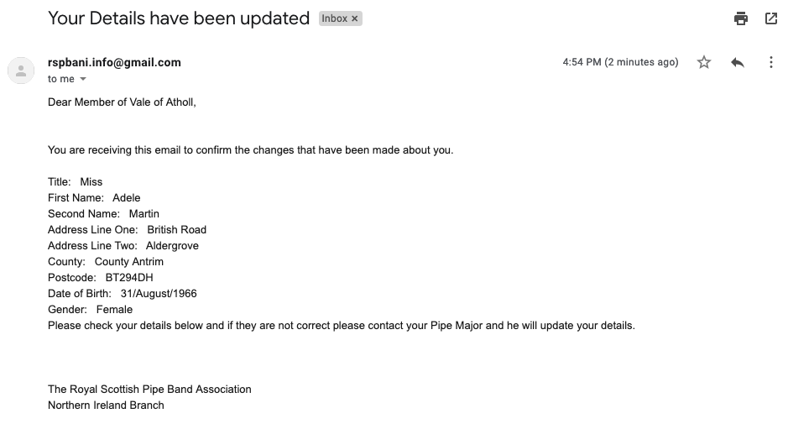

When the band enters a competition, the following output from the system will be sent to the pipe major of the band. I have mocked up the expected output from my system to the pipe major.

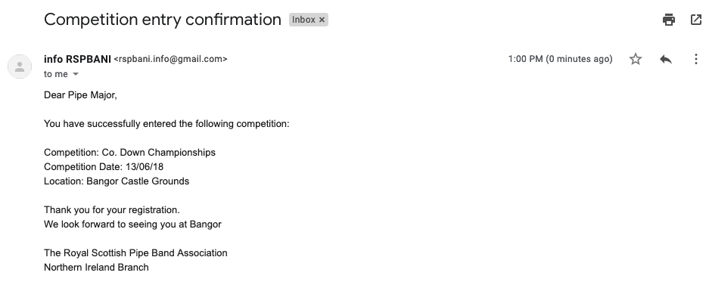

When a band sends an enquiry to the bus company, the details are not stored on the system. Instead an email will be sent to the pipe major with exactly the same information given to the bus company so they a record of what they enquired in case an issue arises between them and the bus company.

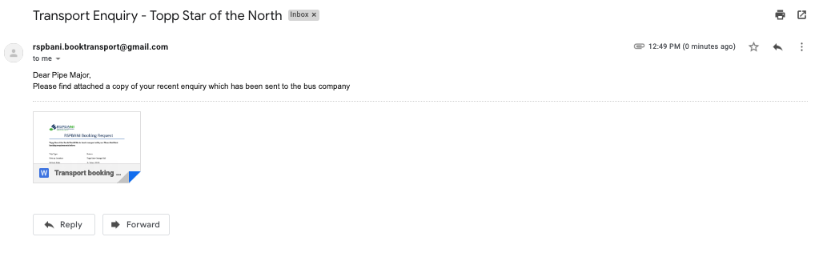

I have re-designed my enter competitions band feature page to allow for the addition of the list of entered competitions and the withdrawal feature.

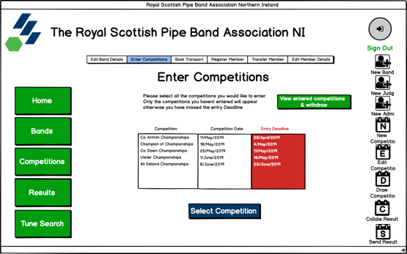The user must simply press the button which says, “View entered competitions & withdrawal” and they will be directed to another page which will show this list of competitions. To withdraw from a competition, they must select the competition by name and press the withdraw button. If their withdrawal has been successful, a message box will appear confirming the withdrawal of the competition and the competition will be removed from the list of entered competitions and will reappear in the list of competitions that the band hasn’t entered if they wish to re-enter again at a later stage. I must also implement an email confirming the withdrawal of the band from the competition.

**Pseudocode for populating the list box:**

START

ListboxCompName = Listbox()

ListboxCompDate = Listbox()

ListboxCompEntryDeadliene = Listbox()

AllCompsDetails = []

# creating list boxes of all competitions entered

ListEnteredCompsID = SELECT CompetitionID FROM BandsEntered WHERE BandID = BandIDofBandLoggedIn

FOR compID IN ListEnteredComps

BEGIN

CompsDetails = SELECT CompetitionName, CompetitionDate, EntryDeadline FROM Competitions WHERE CompetitionID = compID

Add CompetitionName to ListboxCompName

Add CompetitionDate to ListboxCompDate

Add EntryDeadline to ListboxCompEntryDeadliene

NEXT

END

**Pseudocode for withdrawing from a competition:**

START

# withdrawing from competition

ListofCompetitionsIDNotDrawn = SELECT CompetitonID FROM Competitions WHERE Drawn = “False”

FOR CompetitionID IN ListofCompetitionsNotDrawn

BEGIN

IF CompetitionIDSelectedFromListBox = CompetitionID

DELETE FROM BandsEntered WHERE CompetitionID = CompetitionID AND BandID = BandIDofBandLoggedIn

OUTPUT(“Competition has been successfully been withdrawn”)

Send Email

ELSE:

OUTPUT(“Withdrawal has been unsuccessful as competition has already been drawn. You are still entered into the competition”)

NEXT

END

